How to pay by CREDIT CARD

1. After obtaining the participation registration number, please go to the following URL.
https://www.wdc-jp.biz/msf/ps2010/jp/participation.php?t=new

2. You will see a blank column at the bottom of the page like this.
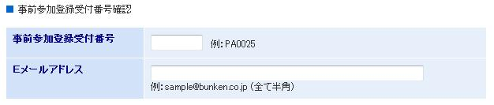
Please enter your participation registration number in the short blank and your e-mail address in the longer blank column.

3. Please click the following button and go to the next page.
Write down your family name and given name in the following column.
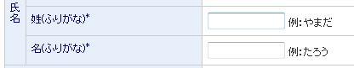

4. If you are a member of Japan Society of Molecular Science choose

If you are not a member, choose

If you are a member, write down your member number.
If you are not a member, ignore it.
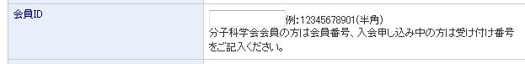

5. Write down your affiliation.
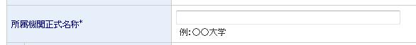

6. Write down your postal code like 560-8531 (for participants in Japan)
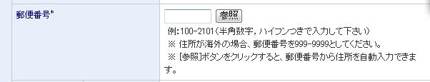

Write down your address.

Write down your telephone number.
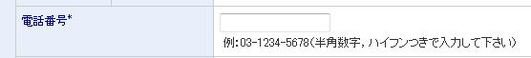

7. To pay by credit card, check the right button.

Click the following button and go to the next page.

8. Check your name, affiliation, address, and telephone number.
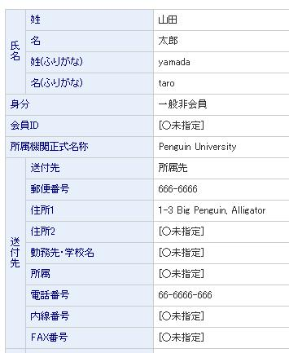
Family name
Member (一般会員) or nonmember (一般非会員)
Given name
Family name
Given name
Membership # (for nonmember, please ignore [○未指定] )

Affiliation (not abbreviated)

Where to send the registration card etc. (Service available only in Japan)
Zip code
Address
Secondary address.
You can ignore last 6 columns, if you do not use second address to choose.

If something is wrong, push the following button to go back to the previous page for revision.

If everything is correct, please insert your credit card information.

8. Write down the card holder's name in capital letter.
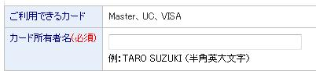

Write down your card number.
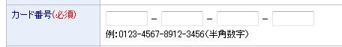

Choose the expiration date (month for the first column and year for the second column).
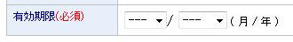

9. Push the following button and go to the final page.

If the following page shows up, your payment is completed. Thank you.
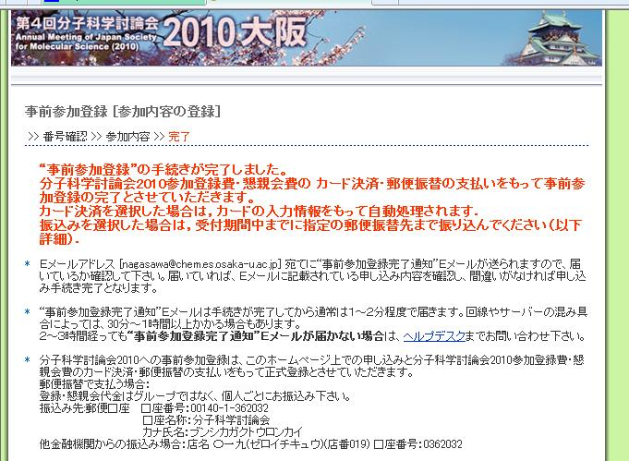

If you have any problem, please call Yutaka Nagasawa at 06-6850-6242
(+81-6-6850-6242 from outside Japan)
(Service not available during 17-25 July)

